42.48: a) First we calculate the number-density of neutrons from the given mass-density:
Now use Eq. 44.21
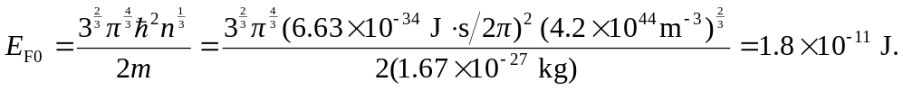
b) Set 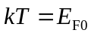(see Exercise 42.26) to obtain
